**ASSIGNMENT 01**

# How to install Web server on Windows machine?

**Sign in to AWS Management Console**

1. Click on the **Open Console**button, and you will get redirected to AWS Console in a new browser tab.
2. On the AWS sign-in page,
   * Leave the Account ID as default. Never edit/remove the 12-digit Account ID present in the AWS Console. otherwise, you cannot proceed with the lab.
   * Now copy your **User Name** and **Password** in the Lab Console to the **IAM Username and Password** in AWS Console and click on the **Sign in** button.
3. Once Signed In to the AWS Management Console, Make the default AWS Region as **Asia Pacific(Mumbai),India ap-south-1.**

**Launching an instance**

* + 1. Go to **Services** on the dashboard then, under the heading **Compute**, click on **EC2**.
    2. Click on **Launch Instance** option.
    3. Under **Name and tags** heading, write instance name.
    4. Under **Application and OS Images (Amazon Machine Image)** heading, select Windows.
    5. Under **Instance type** heading, select t2.micro.
    6. Under **Key pair (login)** heading, click on Create new key pair.
    7. In **Create key pair** menu, enter Key pair name and select Private key file format as .pem and click on Create Key pair option.
    8. **Private key file .pem** will be downloaded.
    9. Leave all settings as default, click on **Launch Instance** option at bottom.
    10. Instance will be created in the instance list.

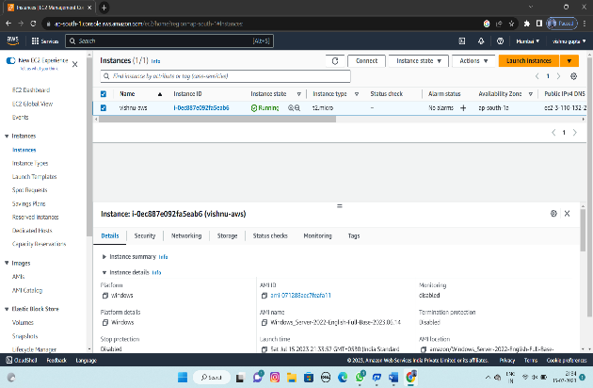

**Connecting Instance**

1. Click on **Instance ID.**
2. Click on **Connect** option. then click on RDP client and download remote desktop file.
3. Now click on get password and click on upload private key.
4. And choose your pem file and upload it.
5. Then click on decrypt password and copy your password .
6. Open your remote desktop file and paste your password.
7. And click on connect now your virtual window will be opened and you are ready to use

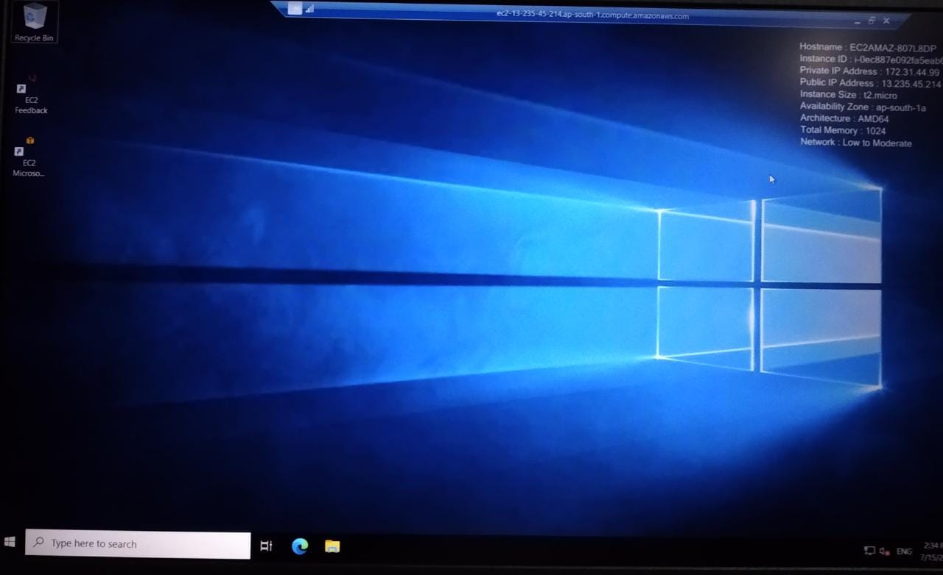

**Installing Web server**

* 1. Open Microsoft Edge on Windows VM.
  2. Download Apache web server installation media in the form of a ZIP file.
  3. Extract the contents of the Apache Web Server 2.4 zip to the file system.
  4. Locate the extracted Apache24 folder and copy this folder to the root of C:\.
  5. Open the C:\Apache24\bin folder and copy the path.
  6. Run CMD as administrator.
  7. Type CD C:\Apache24\bin.
  8. Type httpd –k install then apache will be installed.
  9. Go to Services, click on Apache2.4 and start the service.
  10. Type IP 127.0.0.1 to check web server is working.
  11. If it has installed then it will show “It works!”

